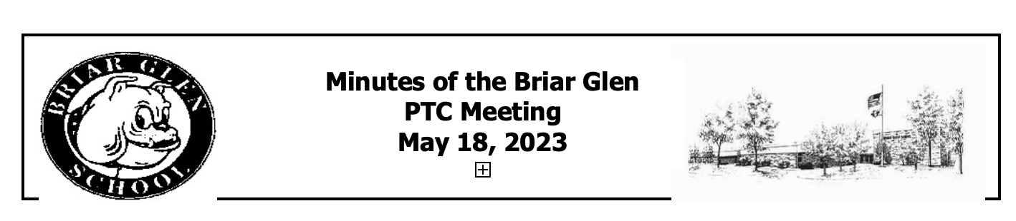

Call to Order: Co-President Billy Cruz called the meeting to order at 7:02 pm.

Attendees-In Person: Billy Cruz (Co-President), Dana Early (Co-President), Amber Norman (Treasurer), Carla Schmidt (Secretary), Mitch Dubinsky, Ashely Doyle, Marianne Buti, Sarah Paletzzo, Sarah Frega, Christyn Esposito, Meredith Mash, Hillary Hoff, Sarah Gemmely, Lee Cuculich, Suzanne Kimerly, Kris Dorger, Lana Surmin, Sarah Troll, Clare Van Wetering,and Hayden Burchard.

Attendees- Virtual: Aimee Bostrand (teacher rep), Megan Jakobsze, Jessica Langman, Ramirez, Kristin Penney, Sapna, Daniel Rimdzius, Mrs. Smitley, Francisco Castillo, and Keven.

Superintendent Report:
Doug is in his second year. He stated that Briar Glen is a great school and always feels welcomed in all capacities. An E–Learning plan was reviewed and accepted at the last board meeting.. It can be used up to 5 days per school year for inclement weather or building issues.

Next, he spoke about safety within our schools. Doug stated that they will be reviewing procedures. Last school year we piloted a new visitor management system that required all visitors to have an ID that would be scanned. With some leftover emergency federal fundings, the district may be able to purchase a system. Every other month or so, the district gets an updated list of sex offenders that the administrative assistants cross reference to be made aware of who can safely access the building. A system would alert us for those that are not safe to be in buildings. This and overall safety will be brought up at the next Board Meeting. Feel free to attend any of those meetings and ask questions. He shared this not to alarm but to bring awareness. Dough thanked the PTC for inviting him to the first meeting of the year and that he has an open door policy for any questions.

Treasurer’s Report/Budget:
Bank Accounts 07/01/24 through 09/19/24
Totals for all accounts: $15,000. This school year we received like $2,380 fees or revenue, coming in. We ended up last year with an actual revenue of 86,000. We had actual expenses of 87,000. We're roughly flat, and that's how we want our budget to be every year. We had some carryover from the year prior. Whatever income we receive we're going to contribute back to the students, the teachers, and the school. For this fiscal year, 24-25, we're projecting a total revenue of 73,000 and total expenses of 73,000. Ultimately, any of these buckets can change. For example, if the Booserthon, which is our largest revenue generating line item, doesn’t get as much revenue as anticipated, then our budget numbers will go down as well.

PTC pays the cost for the Boosterthon company, and then any net proceeds also absorb some of the activities and the items that you see in the budget. We try to identify a couple of different groups to spend the money on. It’s been discussed about a longer term investment towards a new playground that hasn’t been updated. There were no questions, budgets were approved by Clare Van Wetering, Jenny Schubert , and Lee Cuculich..

The treasurer gave the opportunity for questions or suggestions. Also in regards to any events, the treasure has all the official financial paperwork for events and/or chaira for reference. If a cash box is needed, you need to fill out a form 2 weeks prior to the event. If one needs help with this, they can contact the treasurer, Amber Norman.

May Meeting Minutes:
Dana Early motioned to approve the May Meeting Minutes, Suzanne Kimmerly, seconded the motion. May Meeting Minutes were approved unanimously.

President’s Report:
Dana asked everyone to introduce themselves. There no report since the superintendent reported to the PTC.

Principal’s Report:
Mitch welcomed everyone and thanked them for coming in-person or virtually. MAPs reports for grades 1 through 5 were being sent home, Friday, September 20th. Picture Day is Wednesday, September 25th. Lockdown drill is on September 27th with the police department. The students and staff do an amazing job, he has the confidence it’ll all go well. Parent teacher conferences are earlier this year to align with the middle school. Teachers will have sent a Sign Up Genius link to register for conferences. If the time doesn’t work out, feel free to reach out to the teachers. Art Club sign up was a huge success, 64 students signed up and they are no longer taking more. Thanks went to the PTC for their small contribution to the Art Club. Along with the Art Club, there are other clubs at Briar Glen: Student Ambassadors, Fantasy Football, Student Council, and SEL Club. Teachers really enjoy providing for the students and spend their personal time preparing for them.

Teacher’s Report:
Amy Bostrand is the new teacher representative in place of Brianna Garica. Nothing to report. It was stated that she will share any necessary information to the staff and will do the same with the PTC.

Committees:
- Ice Cream Social:
Teachers appreciated the leftover ice cream from the event.

- Kindergarten Playdate:
Was a success. Families were able to meet new families and the students had fun playing together. The plan is to continue this tradition.

- Boosterthon Fun Run:
This year we're raising our goal to $35,000. Goal was created based on the past 3 years. The fun run is our largest fundraiser of the year. We partner with Booster Todd. They are an online platform that makes it easy for us to collect money. They also provide us with fundraising prize incentives, and run the event the day of. It’s a 2 week long program where teachers share a daily character building video. The theme is on being brave and to live with good character. Event kicks off on Monday, September 30th. It’s live now and parents can register their child. The Fun Run is October 10th in the morning. Preschool completes Fun Run in the afternoon.

- Monster Mash:
Saturday, October 26th at Glen Crest Middle School. It was asked to make it from 6:30-8:30 to make it an earlier evening for the little kids. It was approved. Drinks will be provided but not food. There will be a Sign Up Genius for donation and volunteers.

- Classroom Parties:
There are over 200 volunteers. We are still missing Headroom Parents for the following teachers: Lillwitz, Bostrand, Waghorne, Hernandez, White, Ms. Christine, AM and PM, and Ms. Maddie. Emails will be sent out to all volunteers and teachers. 2nd grade teachers will put it in their newsletter that volunteers are needed. Without Headroom Parents, we can’t have a party.

Miscellaneous:
At the end of each meeting there will be raffle prizes for in-person and virtual members. Dana suggested a 10 to 15 minute social gathering before the meeting for members to get to know one another. Members liked that idea. Some may bring treats to share.

If there are questions in the future and/or or have any of how to get involved, please reach out to any board members. These 4 positions rotate out every 2 years. Billy (co-president) and Amber (treasurer) will be rolling off at the end of this year leaving two positions open for the 25-26 school year. Being in any of these positions gets to directly impact change in the school and to work with the amazing staff of Briar Glen.

Next PTC Meeting: October 17, 2024 at 7:00pm. Social time starts at 6:45.

Respectfully submitted,
Carla Schmidt

